AI Assisted Coding (III Year) Assignment
Name: B. Rithwik
HT NO: 2303A52330
Batch: 35

Lab 14 – AI Assisted HTML / CSS / JavaScript Generation

Lab Objectives
- Use AI to assist in designing and implementing fundamental data structures in Python
- Learn prompt-based structure creation, optimization, and documentation
- Improve understanding of Lists, Stacks, Queues, Linked Lists, Graphs, and Hash Tables
- Enhance readability and performance with AI-generated suggestions

Task 1 – Image Gallery Website

Prompt Given to AI

Generate a responsive image gallery website using HTML, CSS, and JavaScript.
Requirements:
• Display images in a grid layout using CSS Grid.
• Add hover zoom effect on images.
• Ensure the gallery is mobile responsive.
• Use clean modern UI styling.
• Provide complete code in a single HTML file.

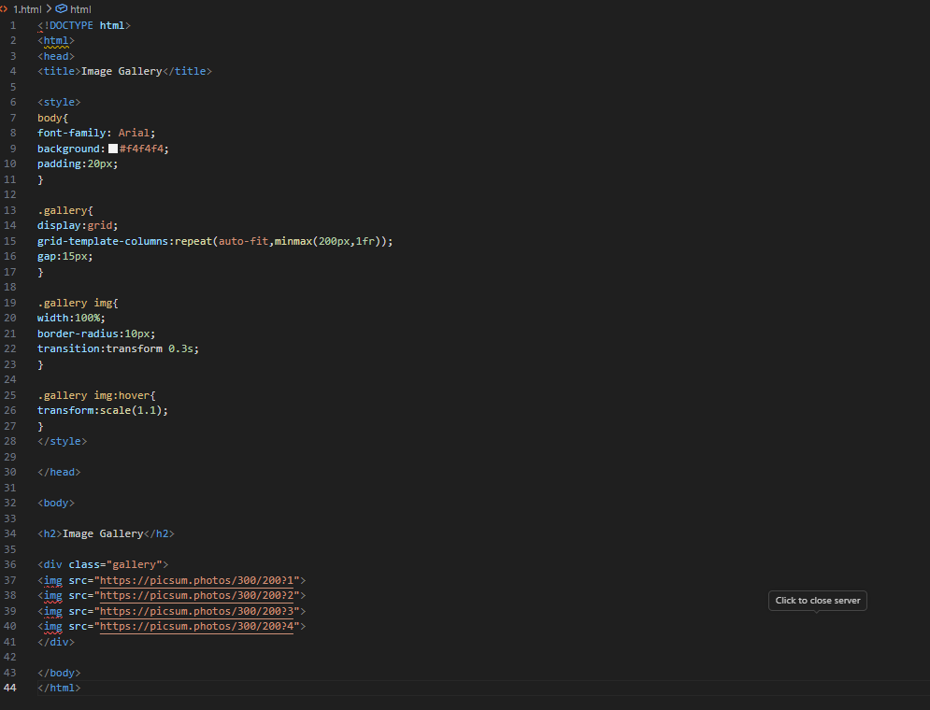

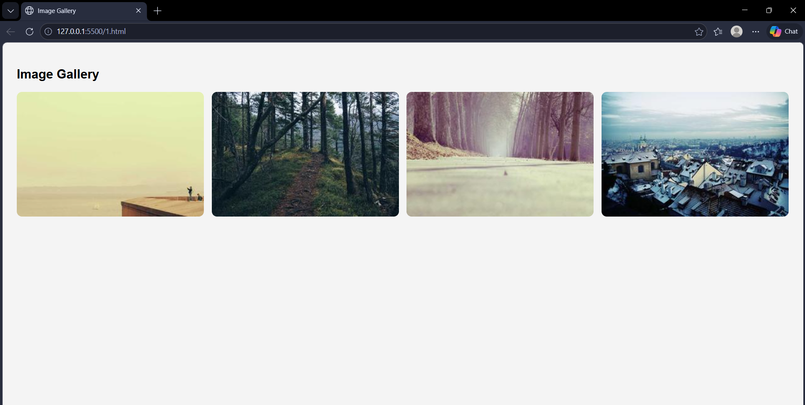

Task 2 – Profile Card Generator

Prompt Given to AI

Create a modern profile card using HTML and CSS.
Requirements:
• Display profile image, name, role, and social media links.
• Use Flexbox for layout.
• Apply modern colors and fonts.
• Add hover animation and shadow effects.
• Provide the complete code.

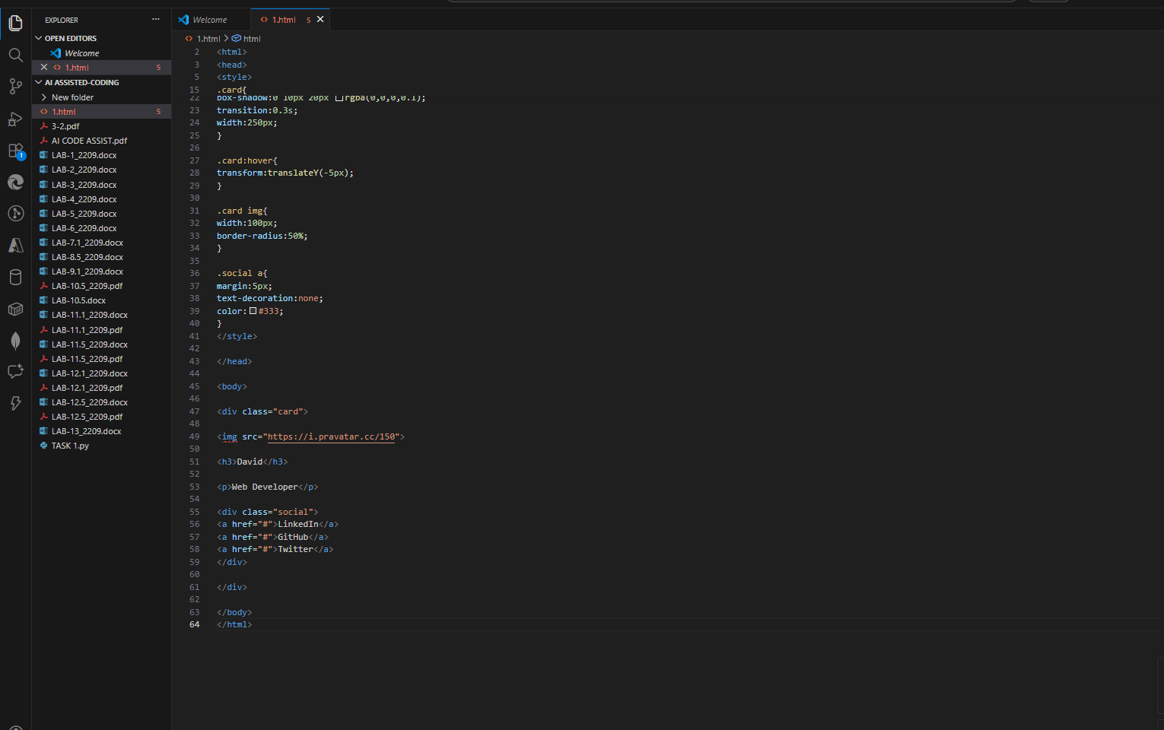

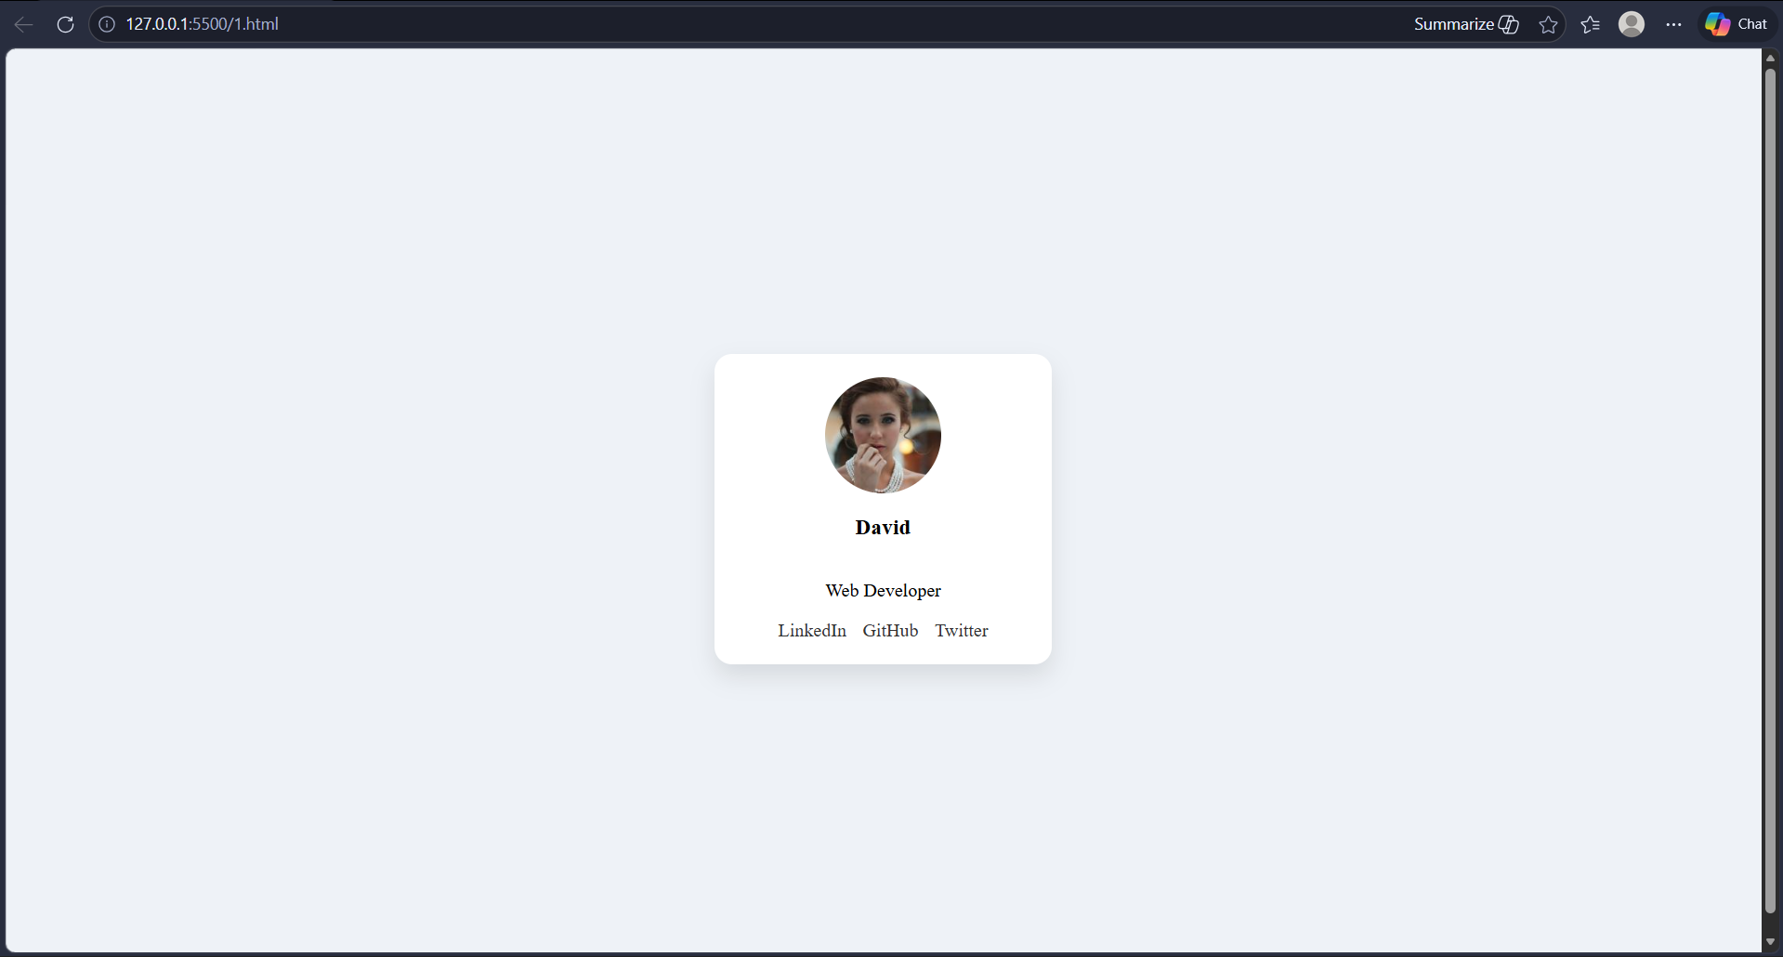

Task 3 – Dynamic Shopping Cart System

Prompt Given to AI

Create a dynamic shopping cart system using HTML, CSS, and JavaScript.
Requirements:
• Add and remove products.
• Update product quantities.
• Display total price dynamically.
• Use JavaScript objects to manage cart state.
• Store cart data in localStorage.
• Provide complete working code.

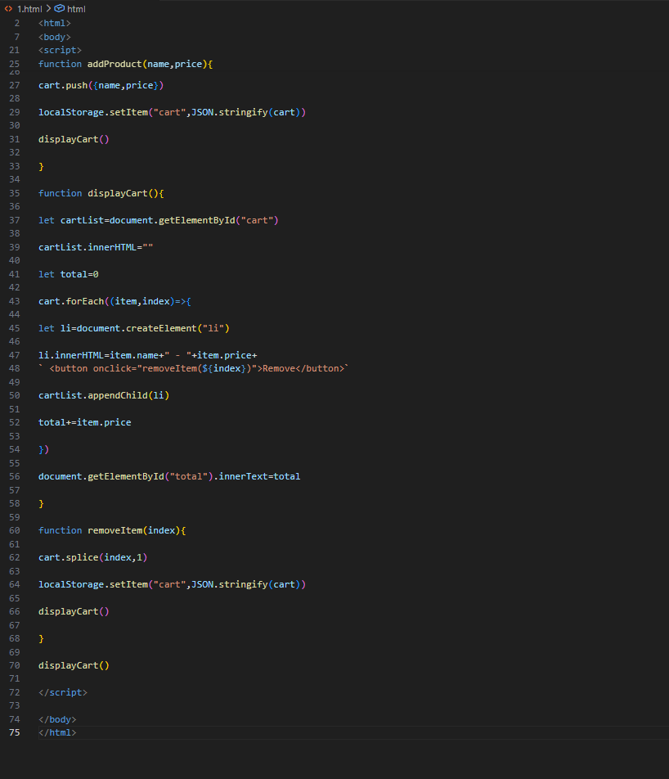



Task 4 – Role Based Access Control

Prompt Given to AI

Create a role-based web application using HTML and JavaScript.
Requirements:
• Support three roles: Admin, Editor, and User.
• Display different UI components based on selected role.
• Implement conditional UI rendering.
• Provide clean and simple code.

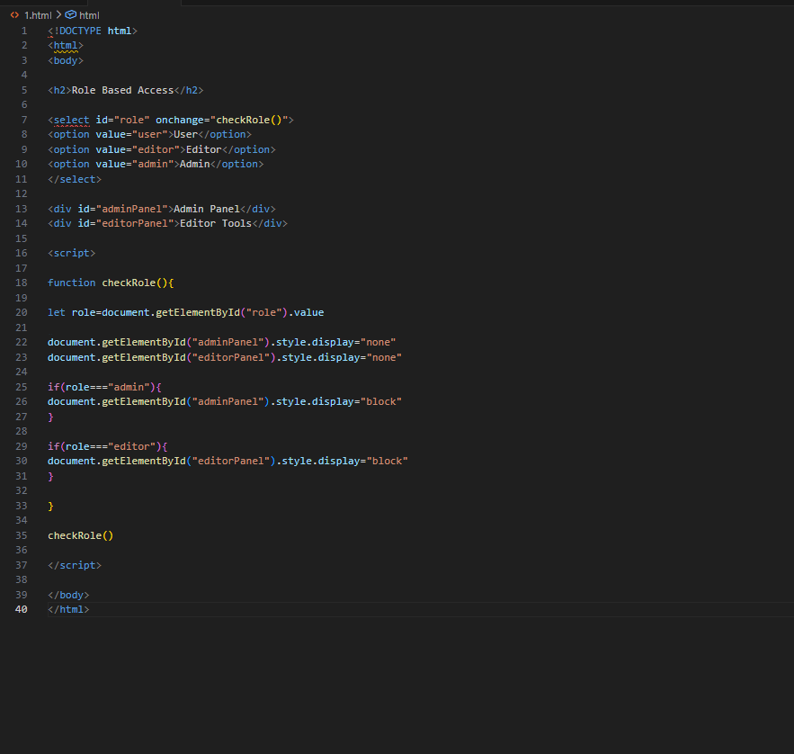

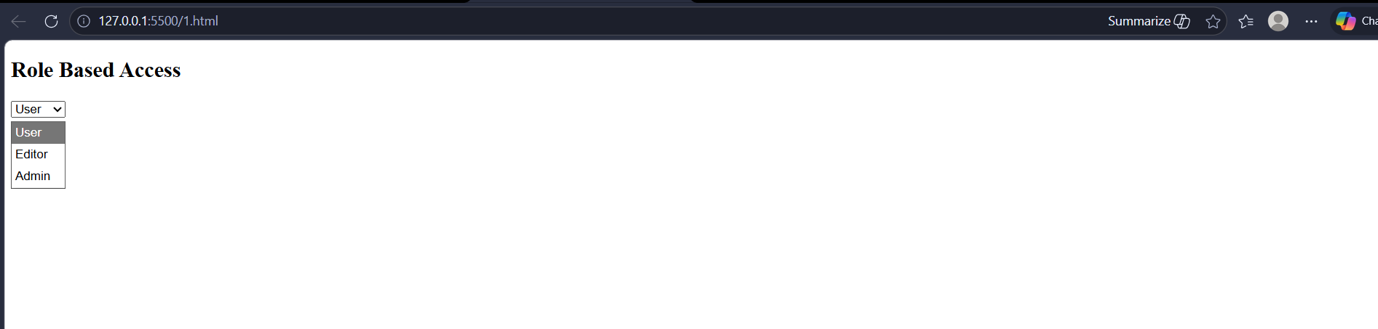

Task 5 – Multi Language Website

Prompt Given to AI

Create a multilingual website using HTML and JavaScript.
Requirements:
• Allow users to switch between languages dynamically.
• Store language preference using localStorage.
• Use a translation object or JSON structure.
• Provide simple example with two languages.

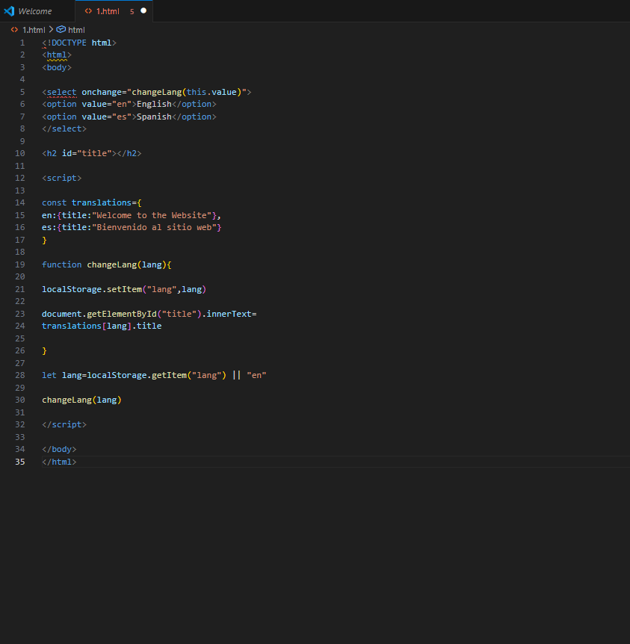

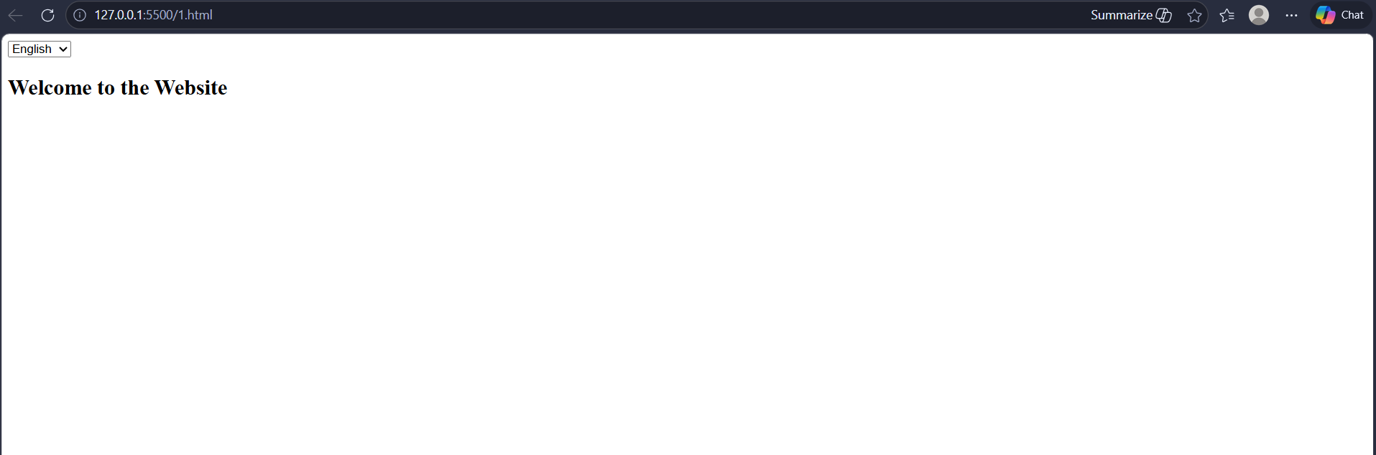

Task 6 – Online Examination System

Prompt Given to AI

Create a simple online examination interface using HTML, CSS, and JavaScript.
Requirements:
• Display a question with options.
• Include a countdown timer.
• Automatically submit when time ends.
• Prevent multiple submissions.
• Show result after 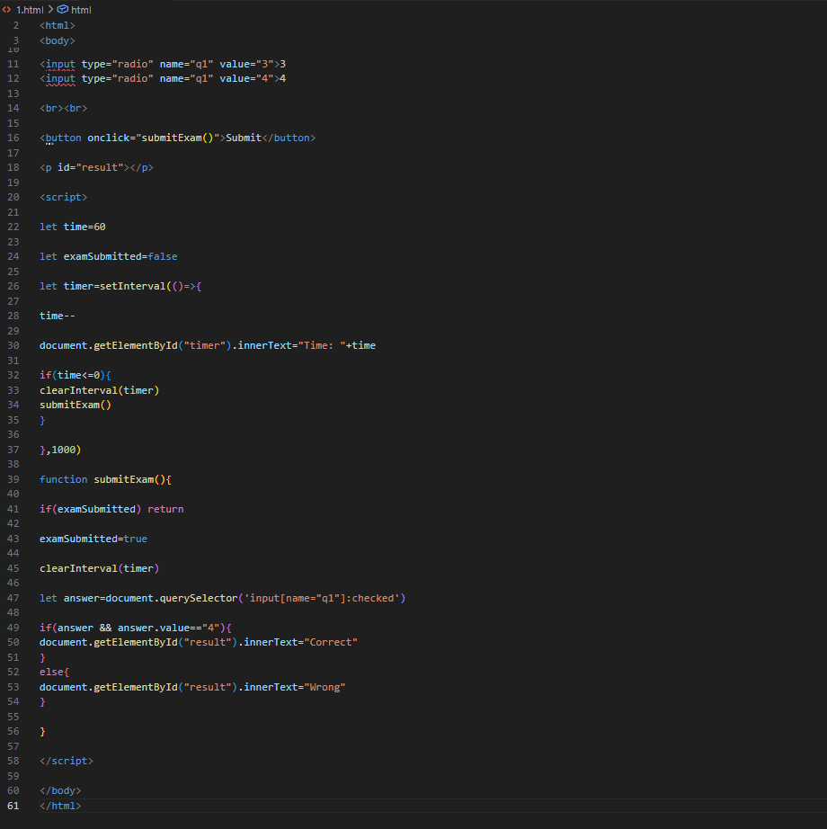submission.



Conclusion

AI-assisted coding tools help developers rapidly generate responsive UI layouts, optimize JavaScript logic, and implement modern web development practices. Using HTML, CSS Grid/Flexbox, and JavaScript, developers can build interactive and scalable web applications while improving usability, responsiveness, and performance.

